Ecilipse: [Eclipse 4.6 (Neon)](https://www.eclipse.org/eclipse/development/readme_eclipse_4.6.php) and jdk1.8.0_1012

In the configuration file of ecilipse change the java path. Here it is changed to D drive.

NOTE: Eciplise and jdk version should be of same bit version i.e if ecilipse is 64bit and jdk should be 64bit.

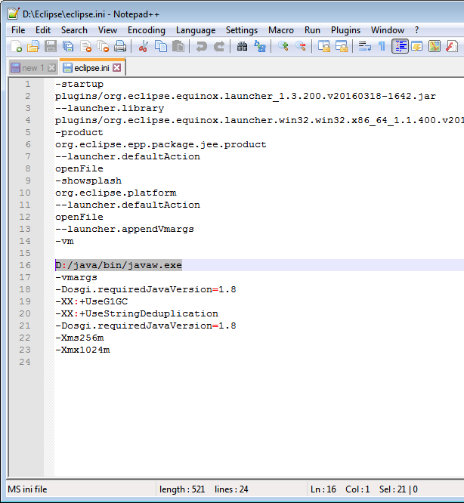

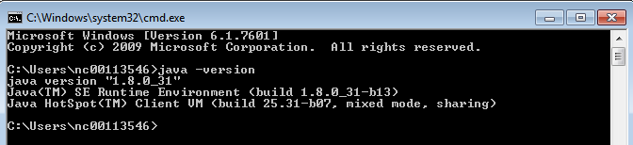

Select a Repository using search option and fill the details

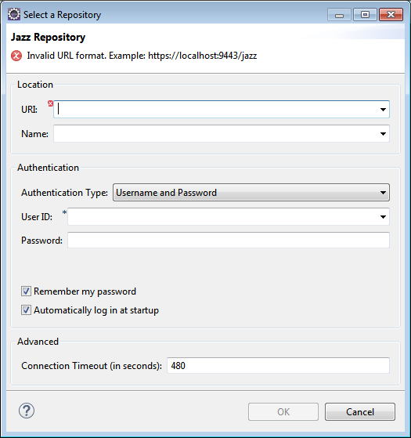

And in the next step select the project and click ok

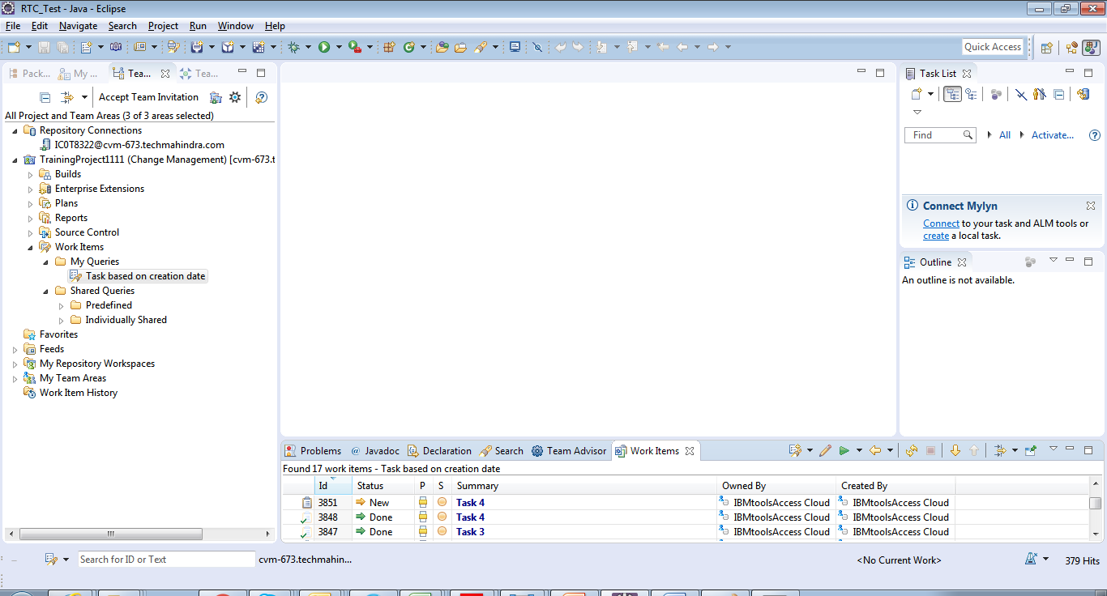

Choose a Project: Login to CCM application and Select a Project

Project: TrainingProject1111 (Change Management)

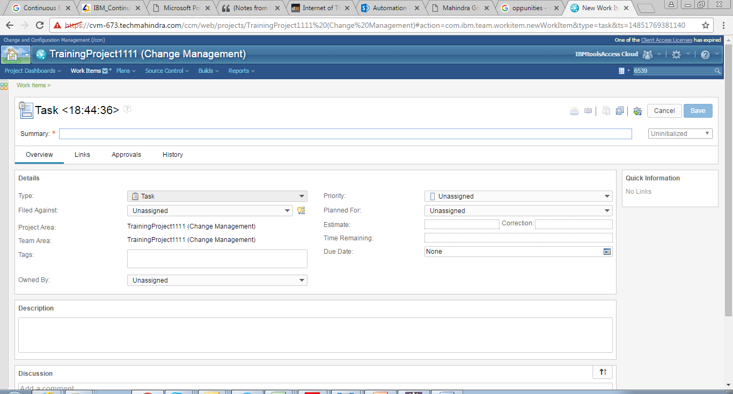

Create a CSV file as per the Work Item template

Work Item = TASK 

|  |  |  |  |  |  |  |  |  |  |  |  |  |  |
| --- | --- | --- | --- | --- | --- | --- | --- | --- | --- | --- | --- | --- | --- |
| Summary | Type | Field Againest | Project Area | Team Area | Owned By | Priority | Planned For | Estimate | Correction | Time Remaining | Due Date | Description | Discussion |
| Import from csv file via ecilipse-check1 | Task | TrainingProject1111 (Change Management) | TrainingProject1111 (Change Management) | TrainingProject1111 (Change Management) | IBMtoolsAccess Cloud | Low | Sprint 1 (1.0) | 1h | 3 h | 3 hours | Jan 24, 2017, 3:00:00 PM | Import from csv file via ecilipse to validate | Import from csv file via ecilipse for future discussion |
| Import from csv file via ecilipse-check2 | Task | TrainingProject1111 (Change Management) | TrainingProject1111 (Change Management) | TrainingProject1111 (Change Management) | Raviraj Dumakimath | High | Sprint 1 (1.0) | 1h | 2 h | 2 hours | Jan 28, 2017, 3:00:00 PM | Import from csv file via ecilipse to validate | Import from csv file via ecilipse for future discussion |

Using the ‘Import’ wizard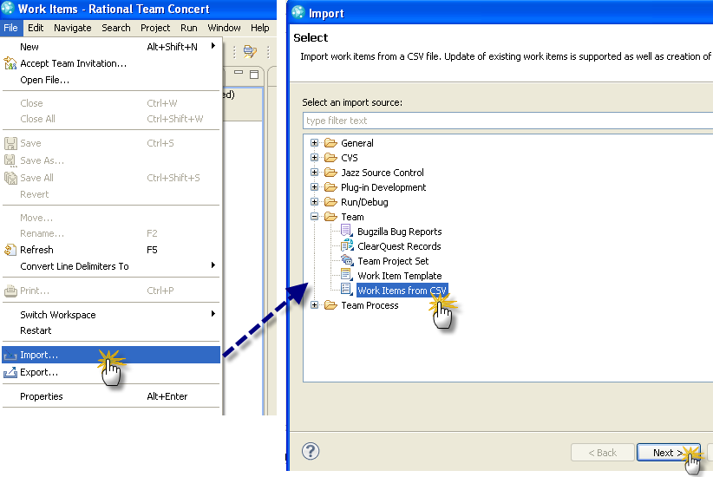

Options to be chosen from the import wizard

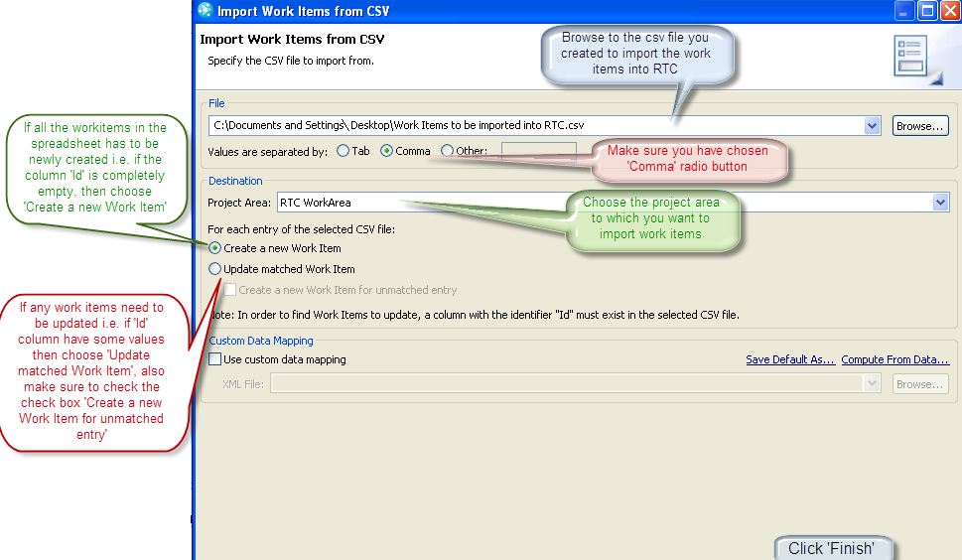

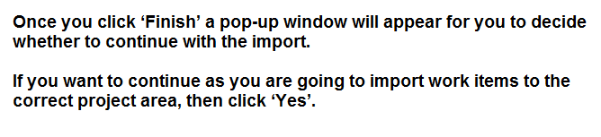Importing into remote repository

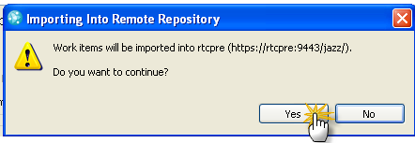

Completion of import operation



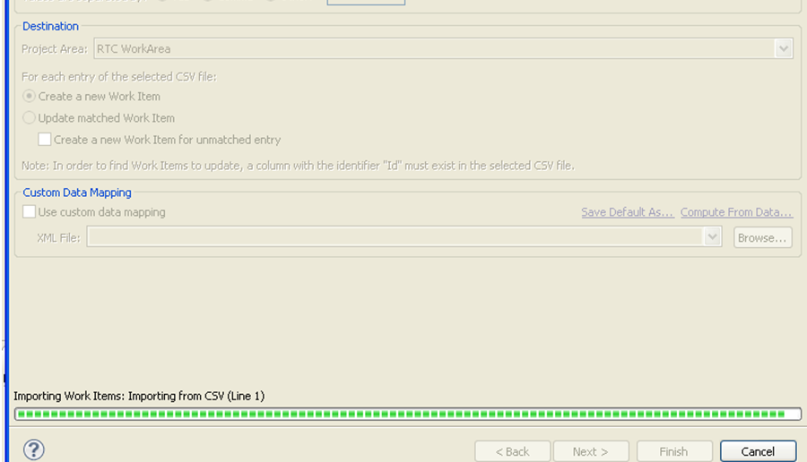

Verifing the IMPORT OPERATION:

Using Eclipse:

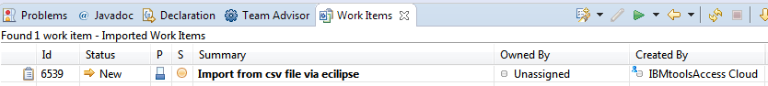

Using a Query/Search Option in CCM:

From above a Work Item ID: 6539 is created and searching the same in CCM.

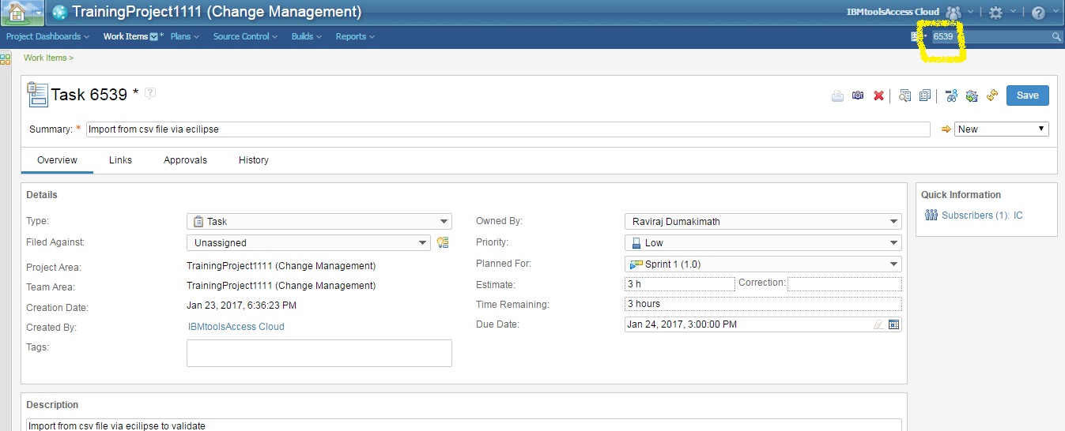

Using a Search Option in CCM:

